**Lab Practical #05:**

Study the concept of VLAN using packet tracer.

**Practical Assignment #05:**

1. **Implement the different network structures in VLAN and VLAN trunking. Also check connectivity between them using ping command or PDU utility.**

**Instructions:**

1. Different VLANs configuration setup screenshot. (VLAN example given by lab faculty)
2. Write steps to create VLANs in packet tracer.
3. Mention IP address of each pc as label.
4. Ping command or PDU screenshot between two VLANs.
5. VLAN SETUP-1

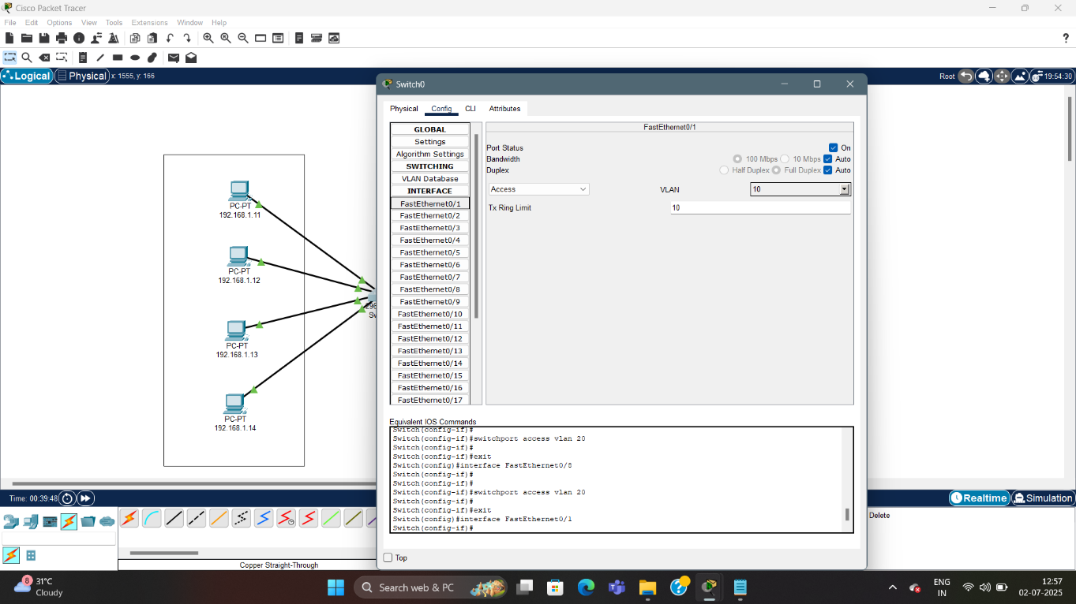

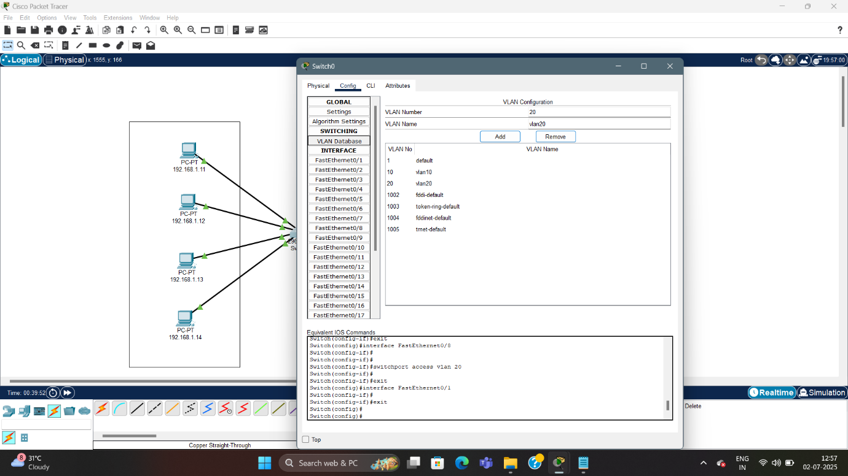

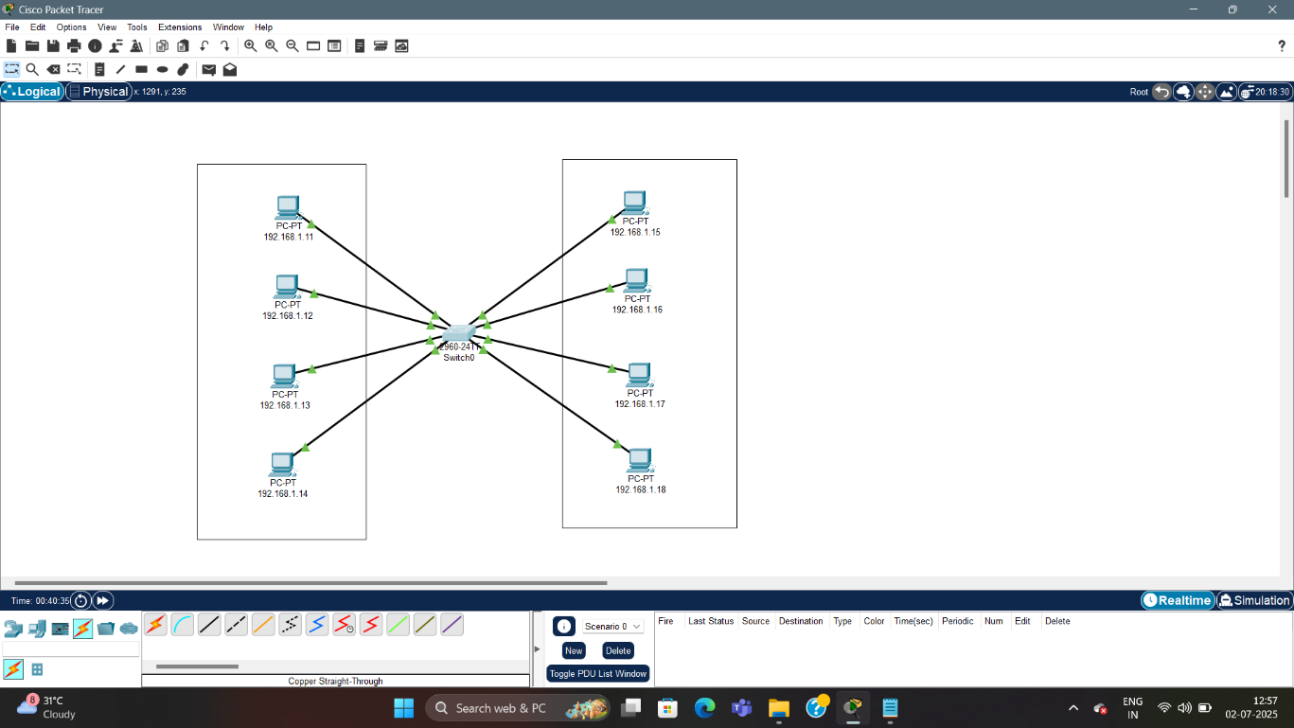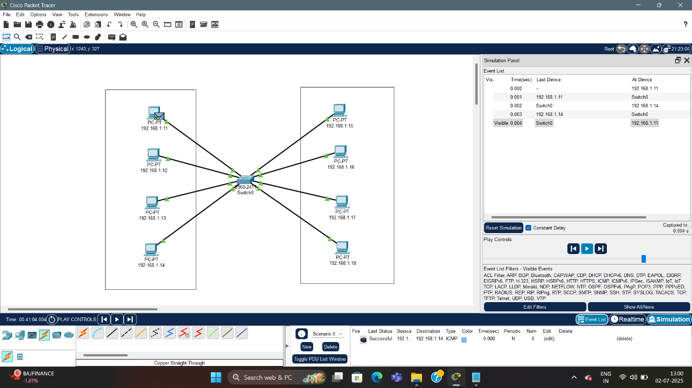

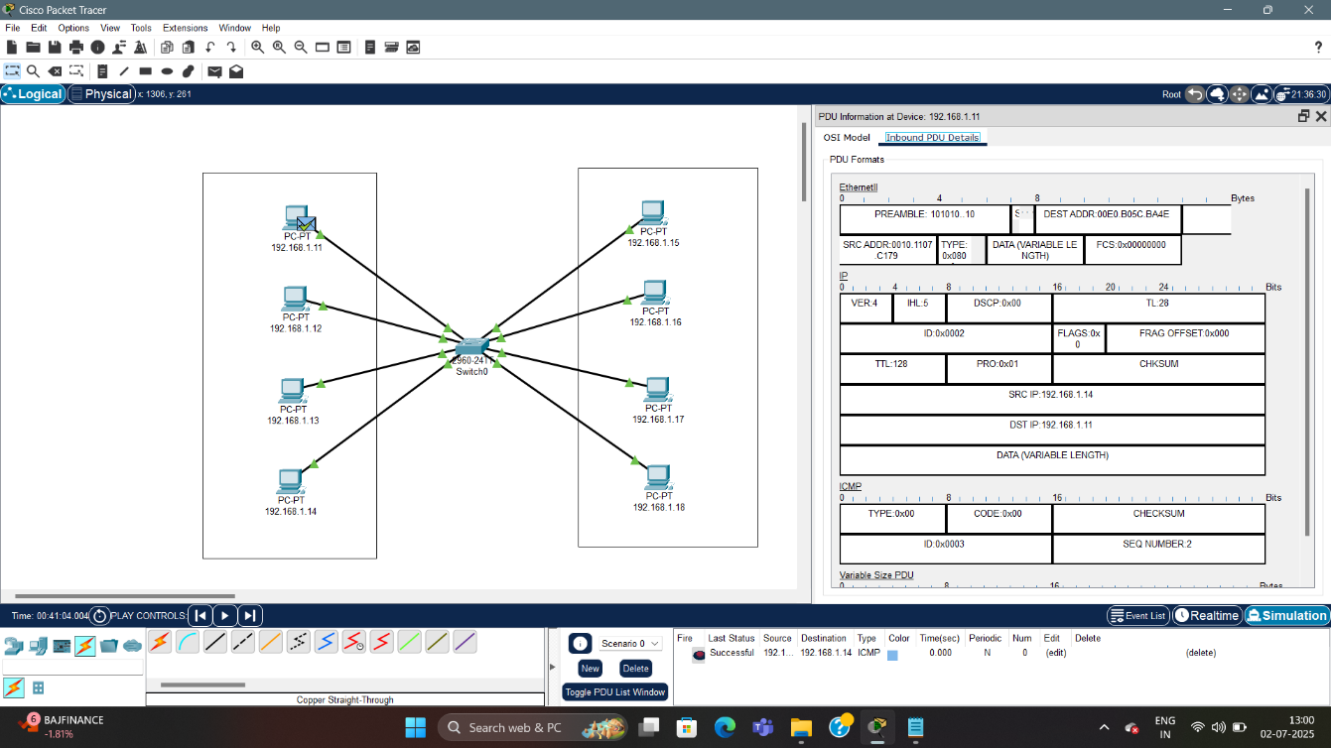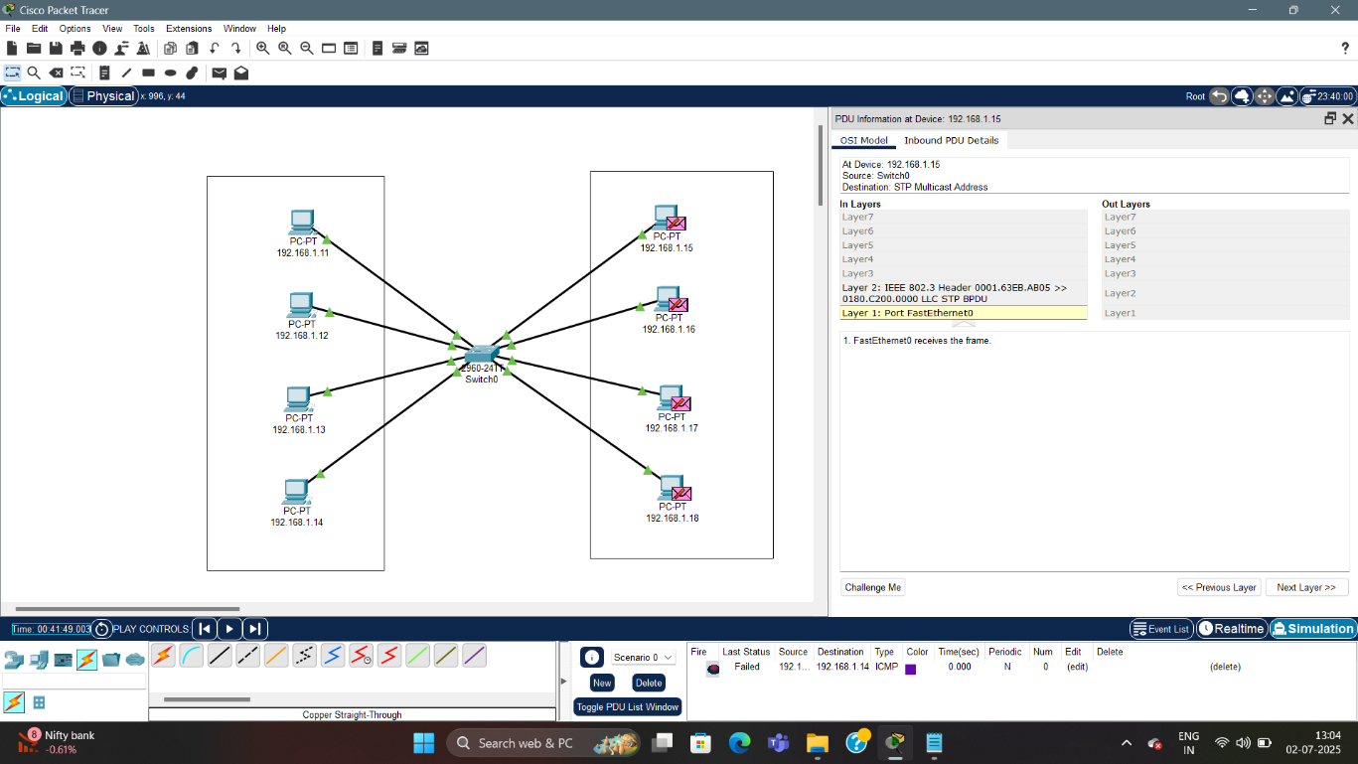

2.VLAN SETUP-2

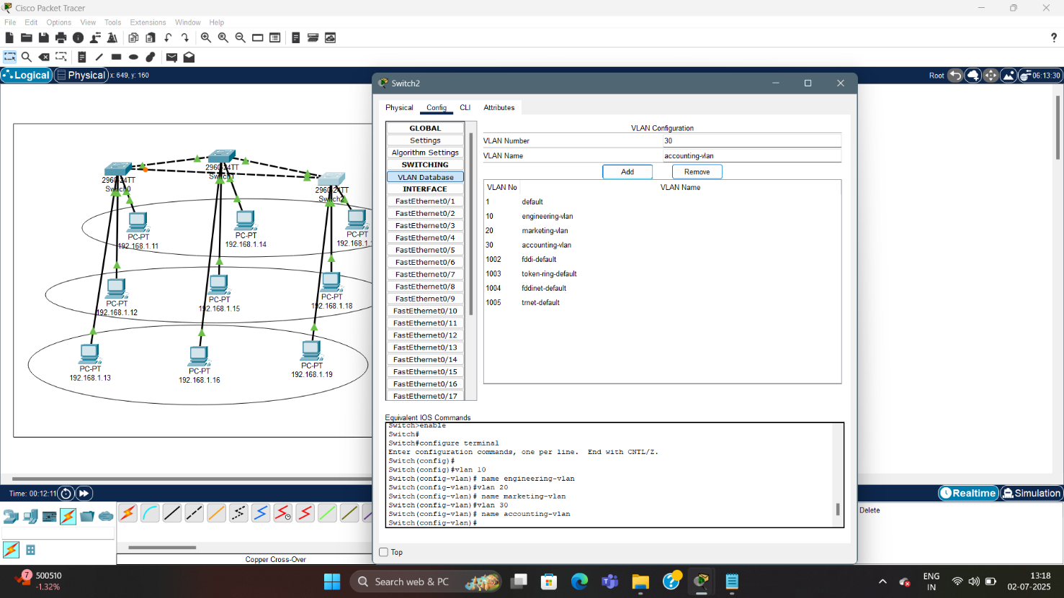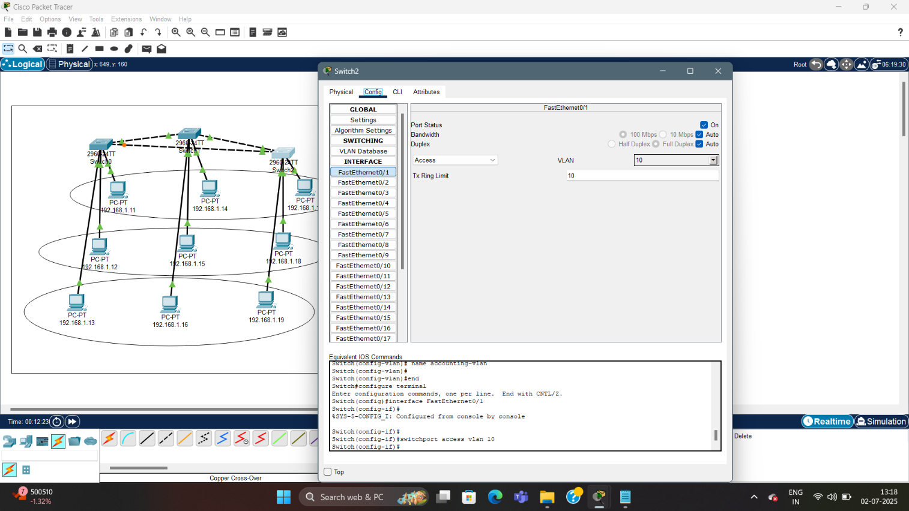

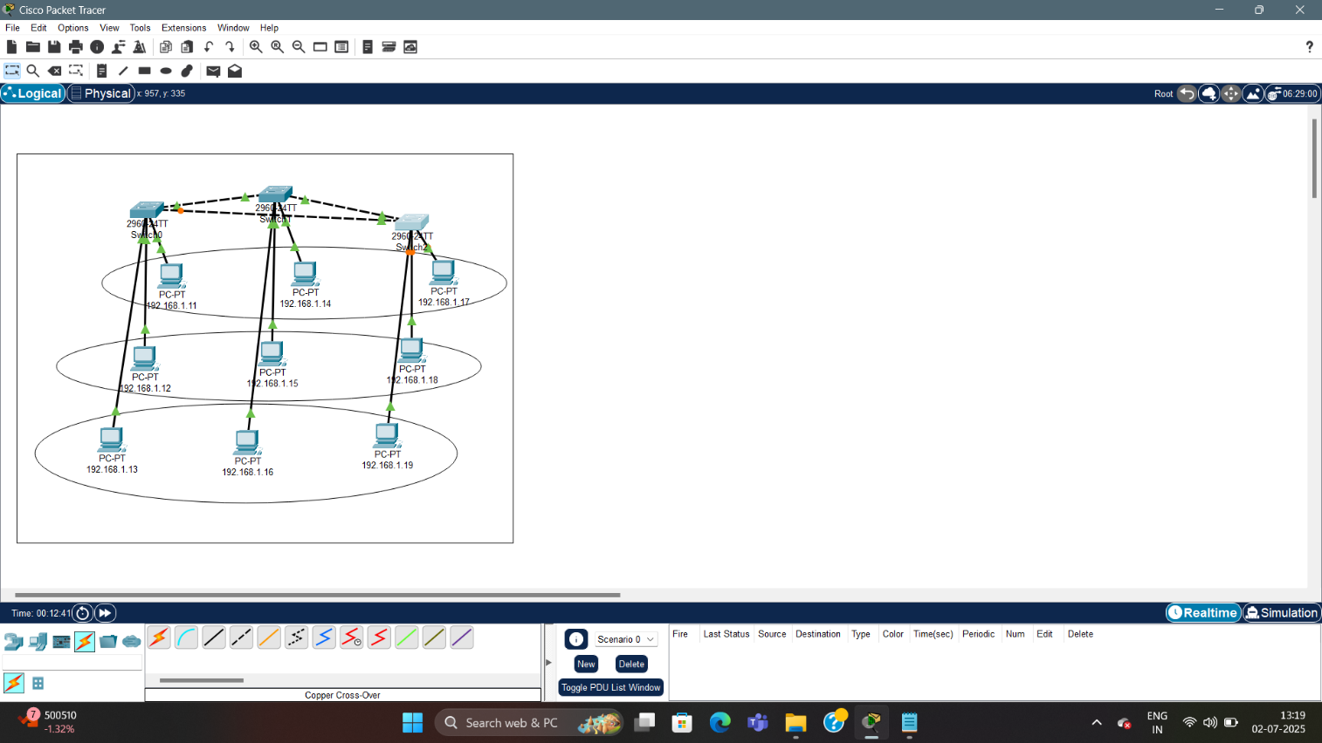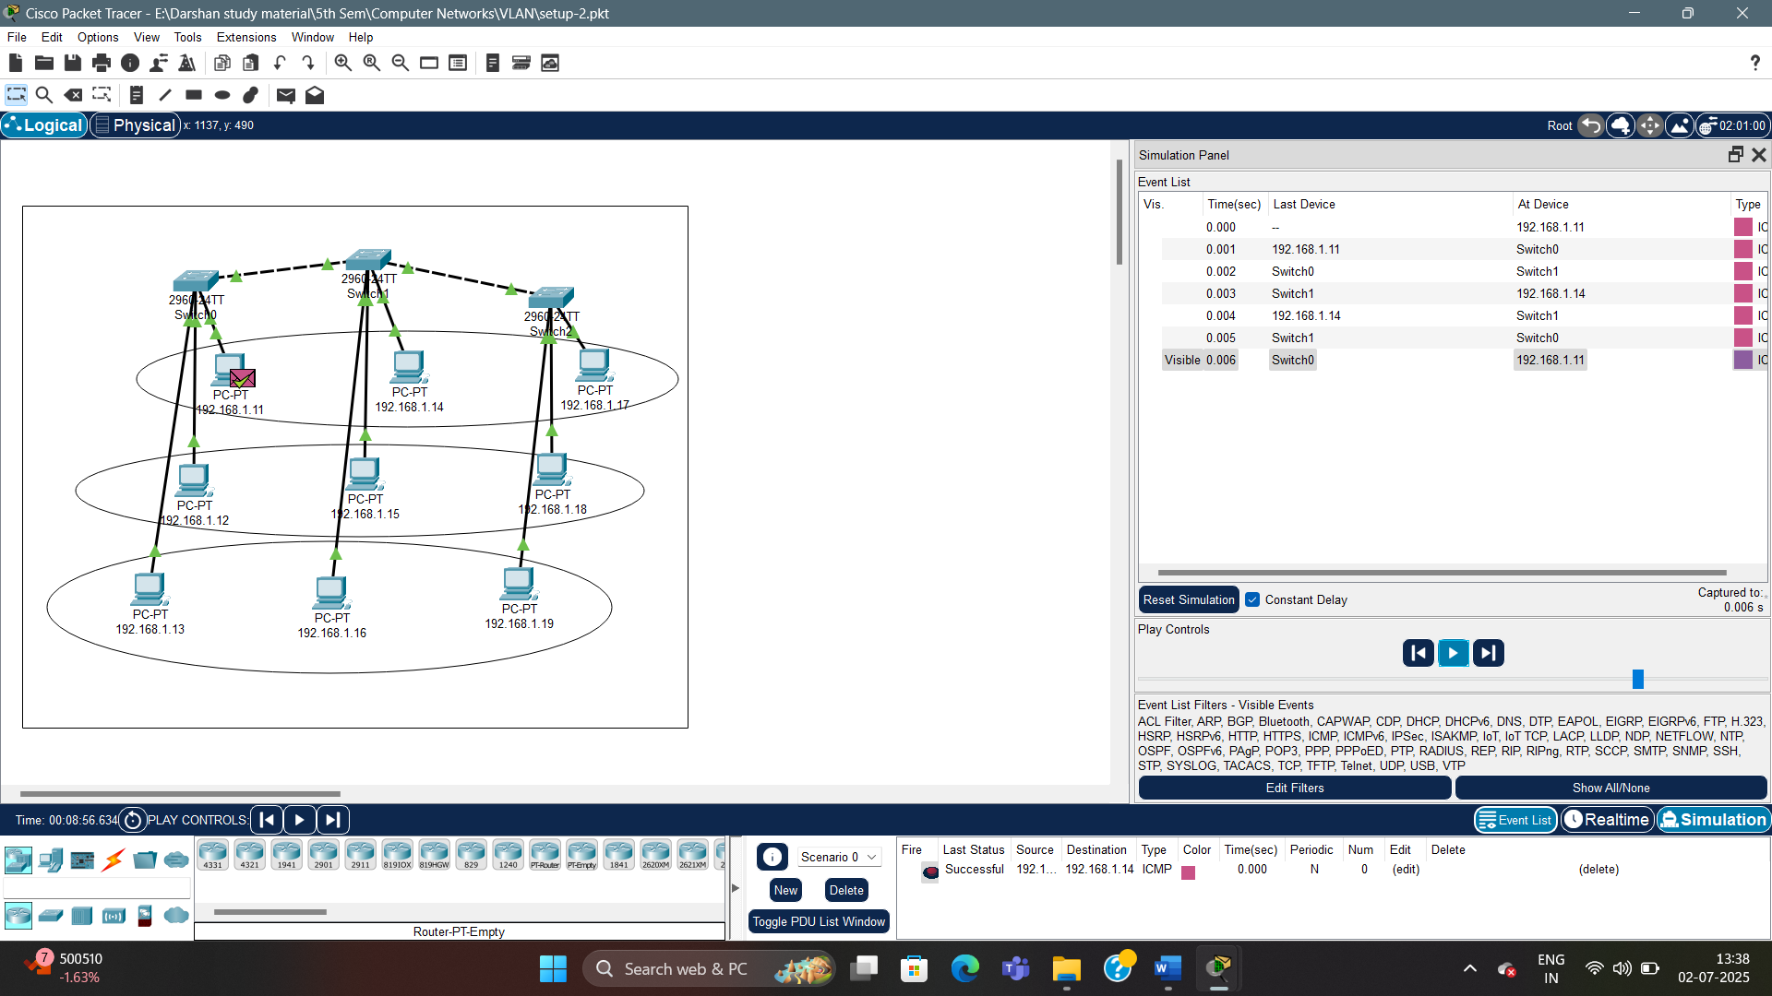

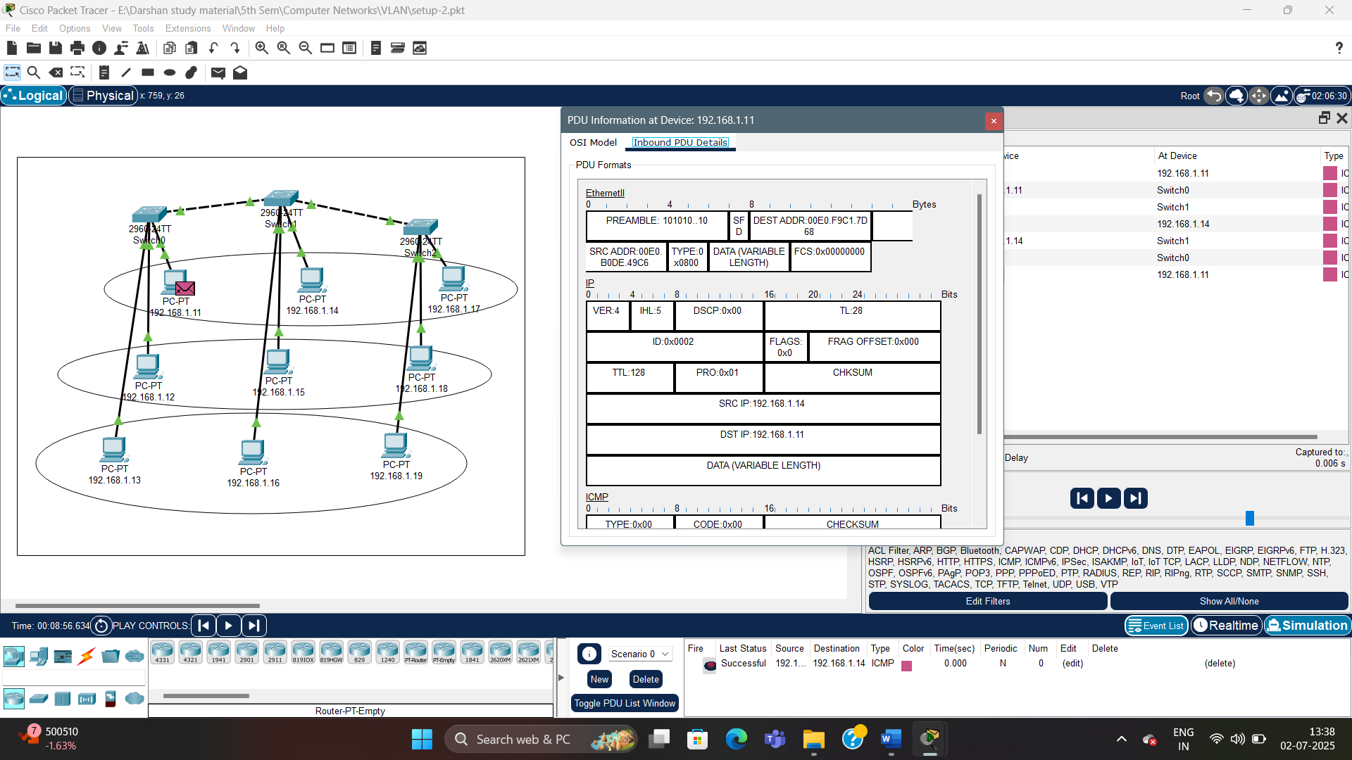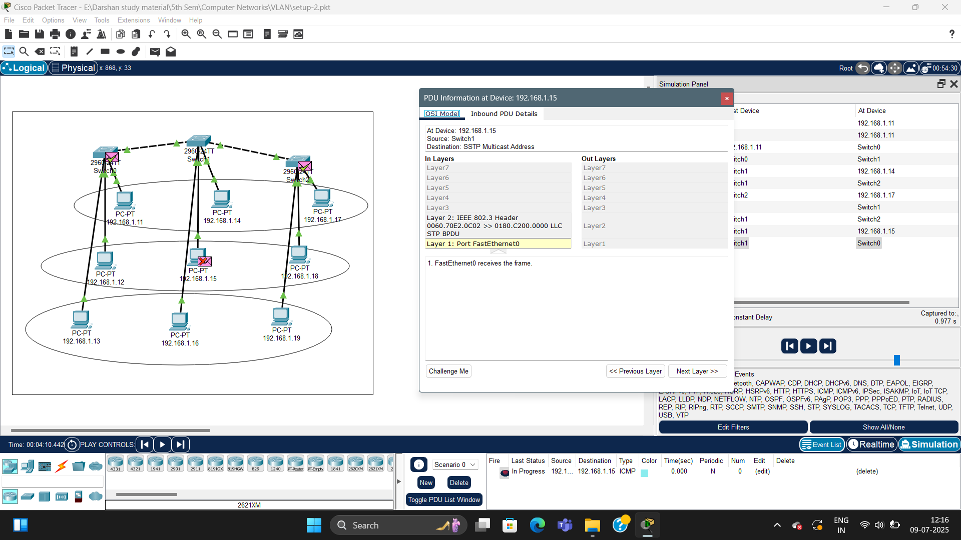

3. VLAN SETUP-3

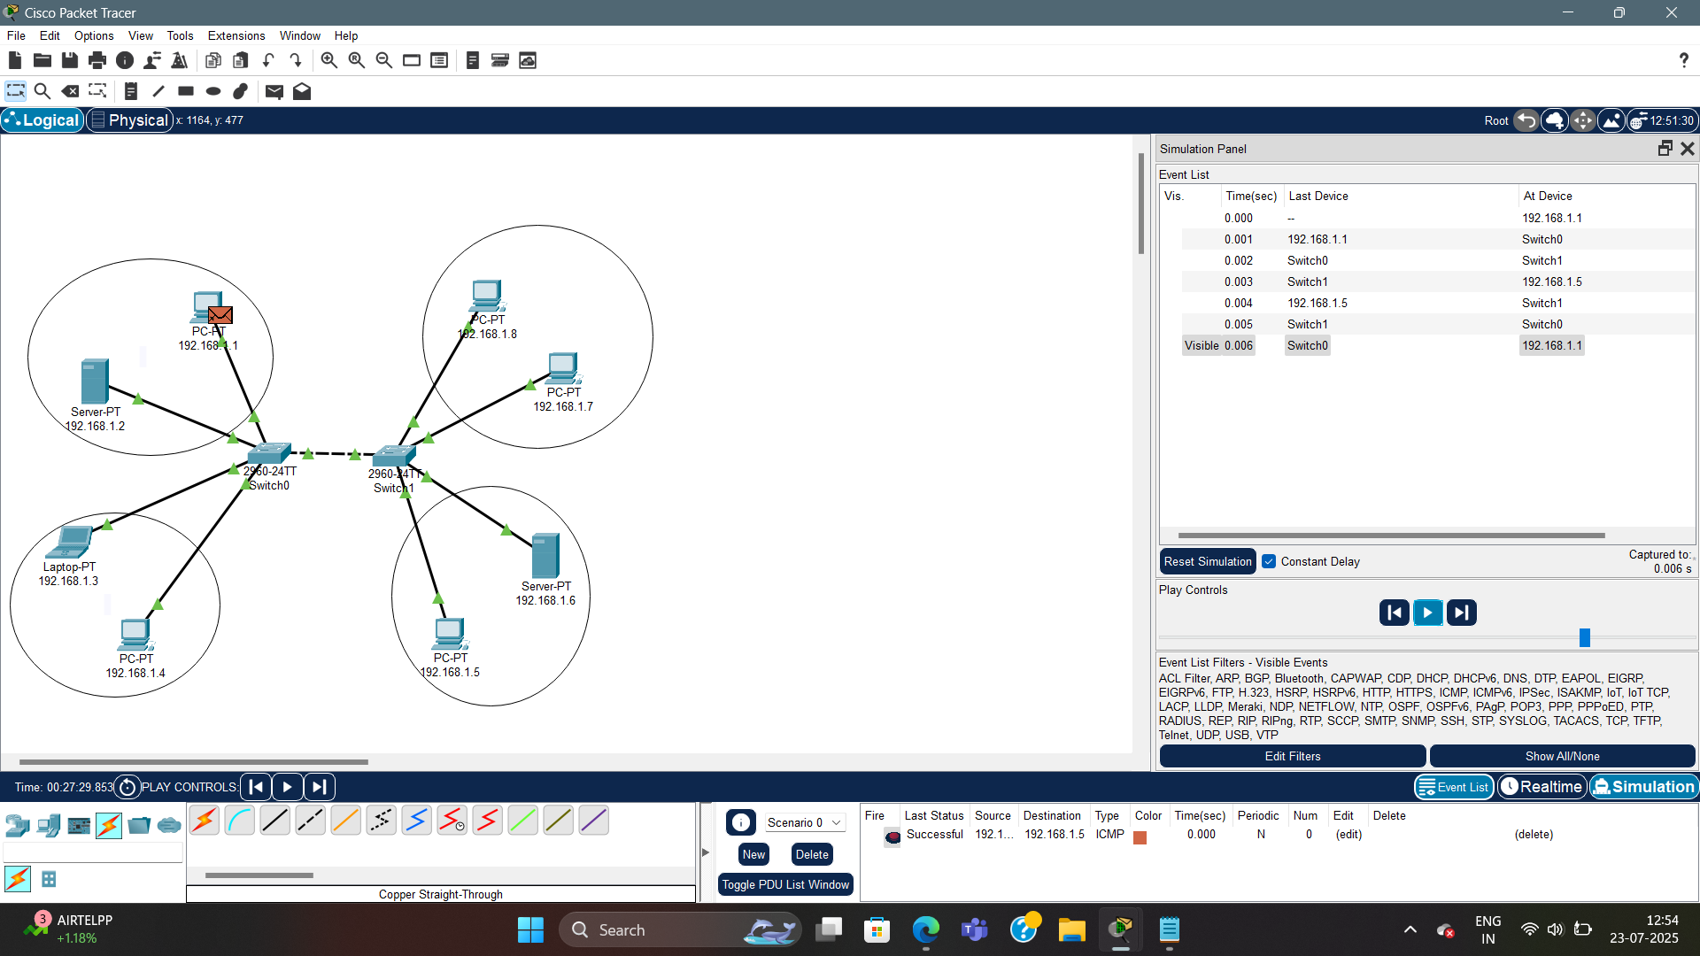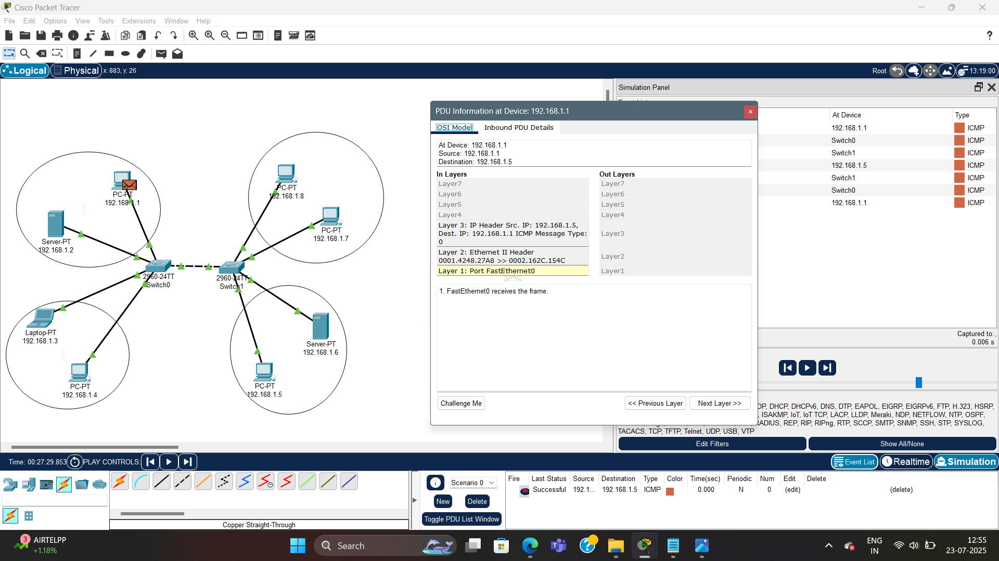

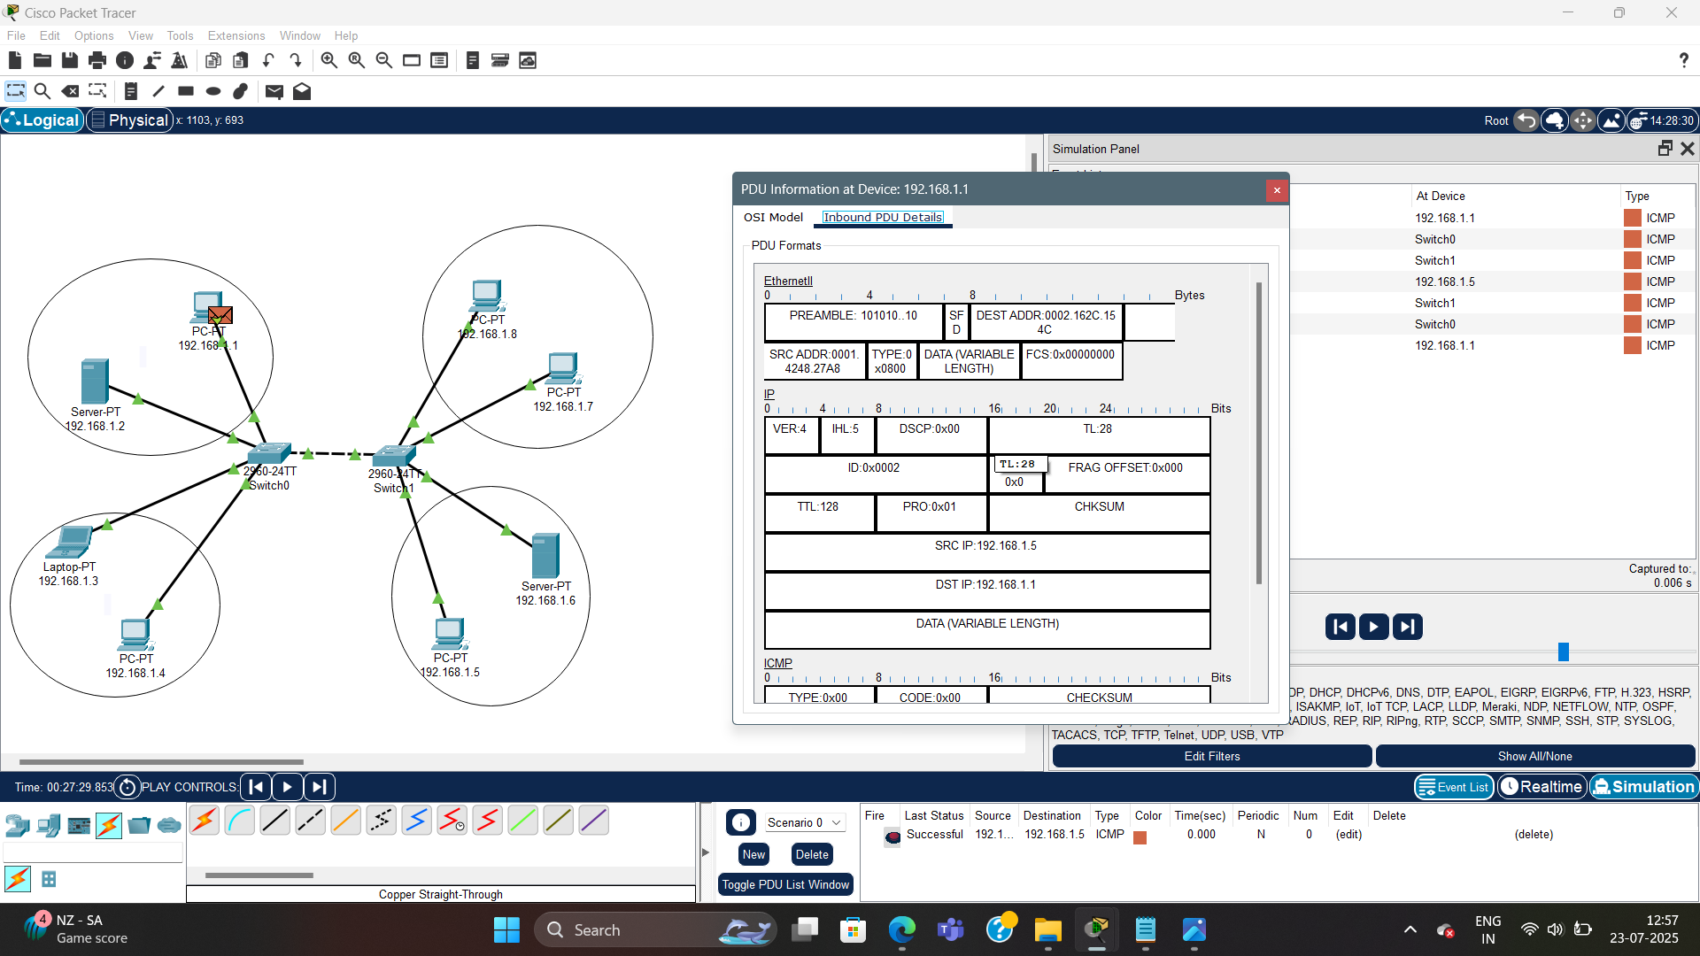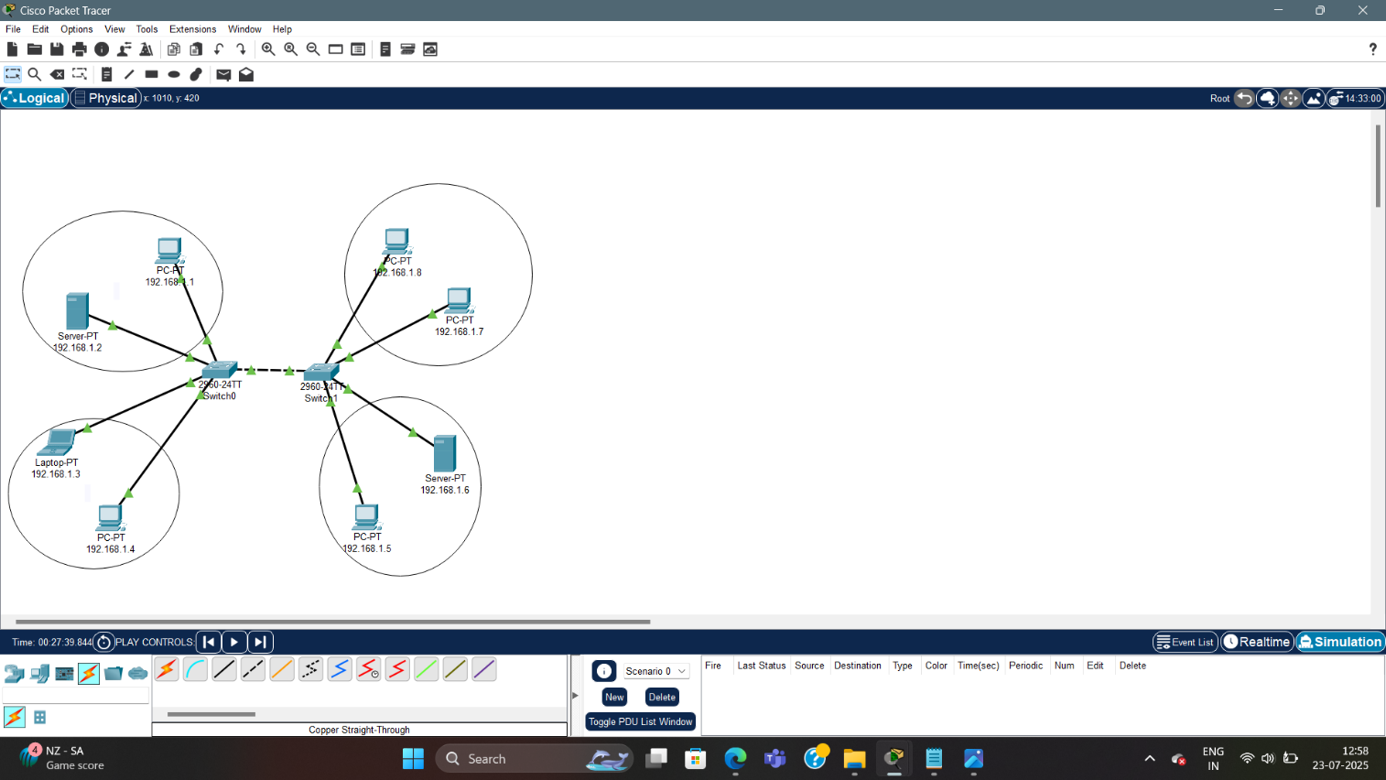

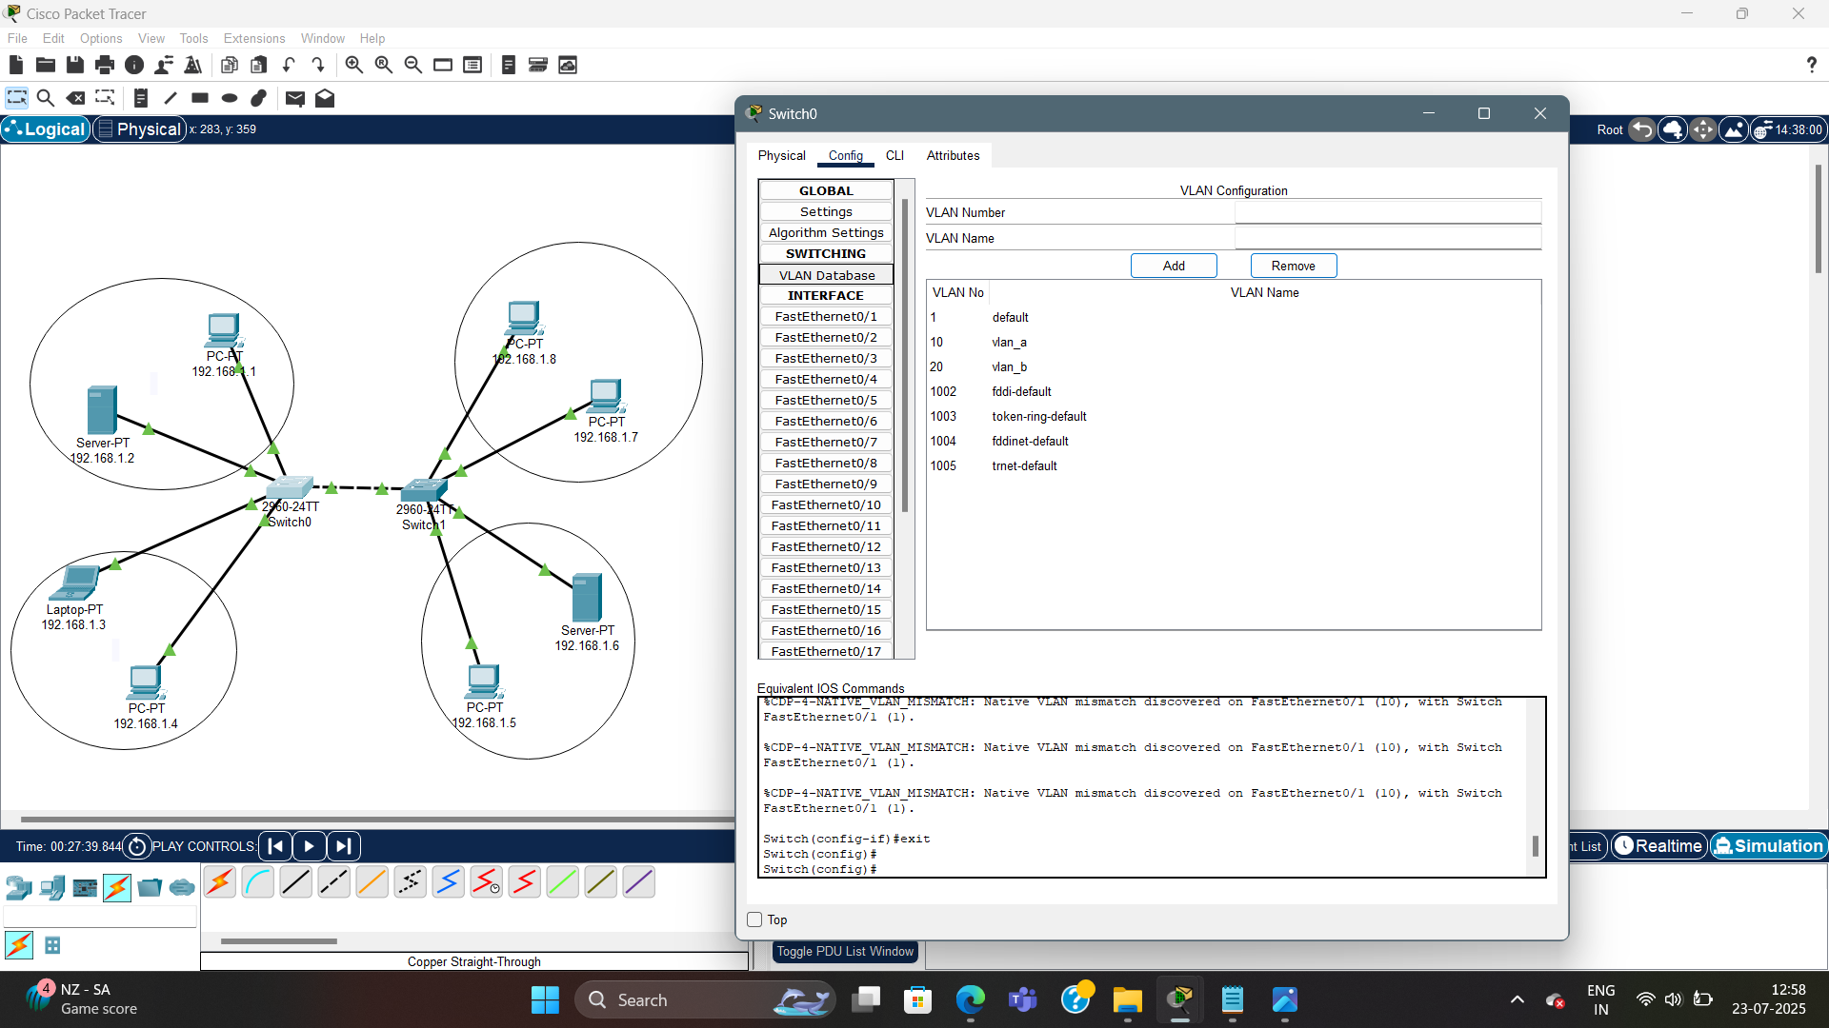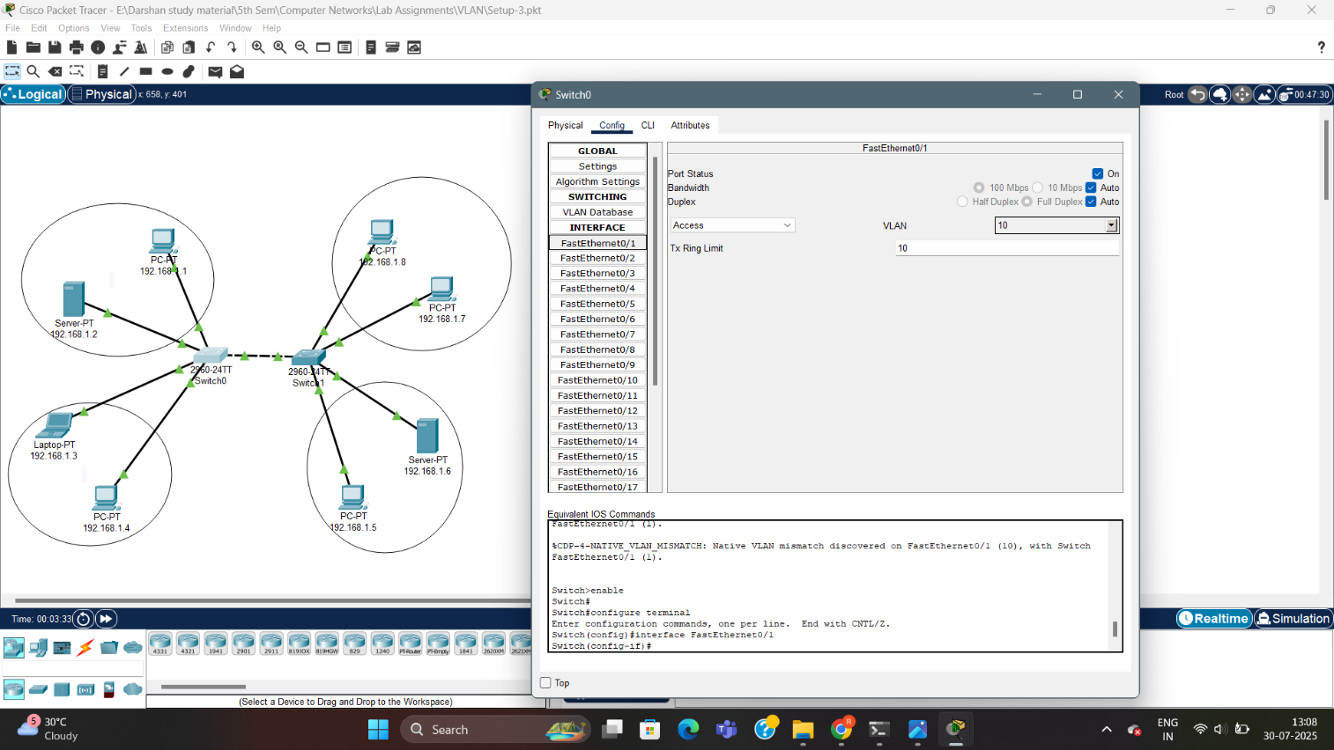

4. VLAN SETUP-4

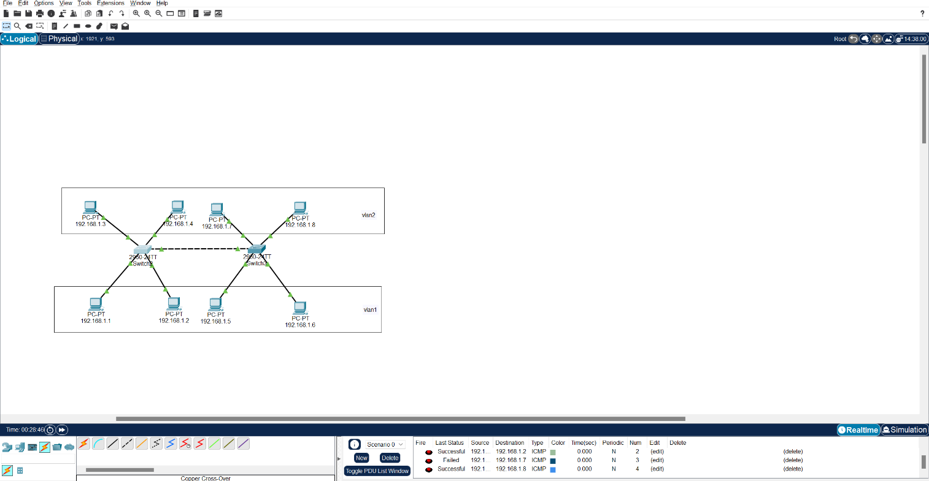

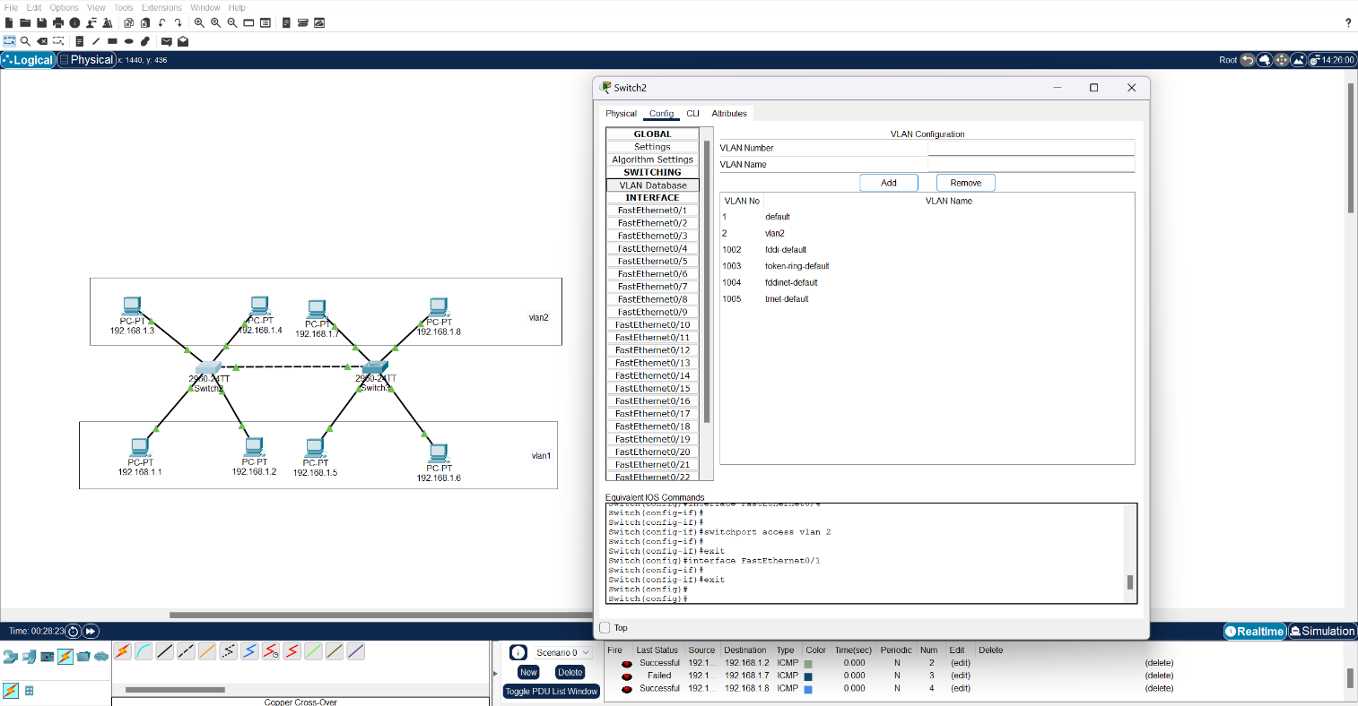

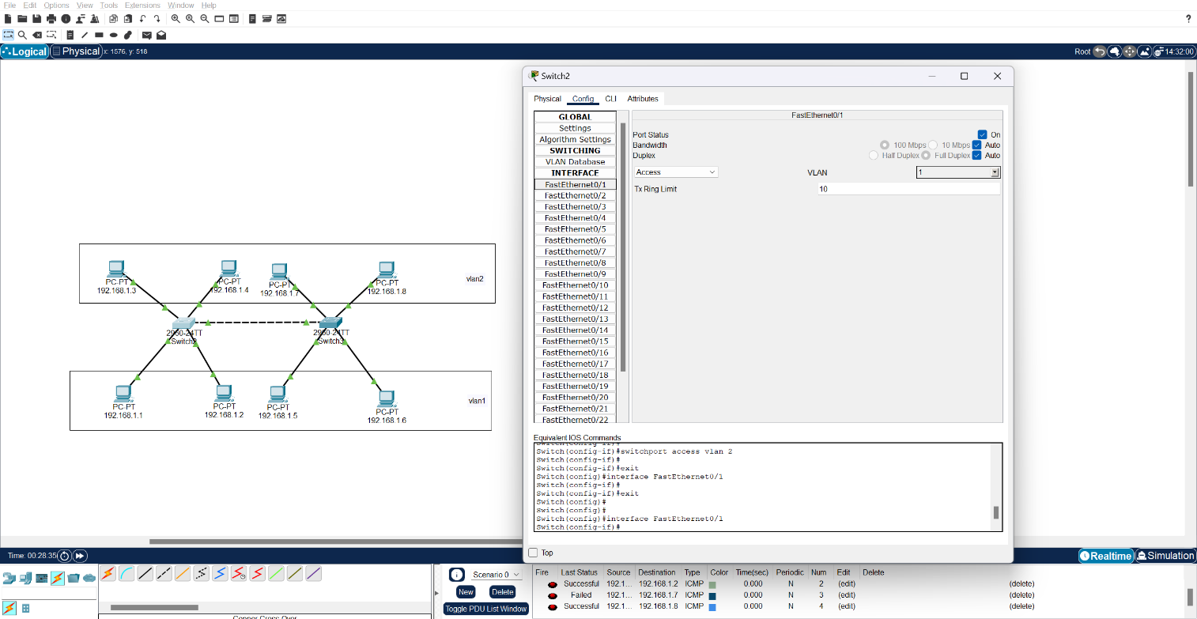

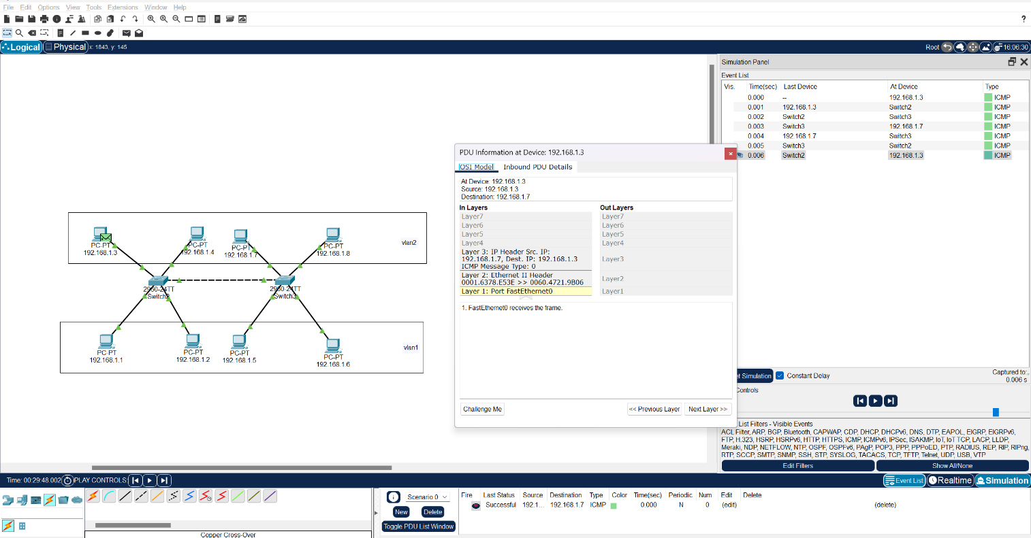

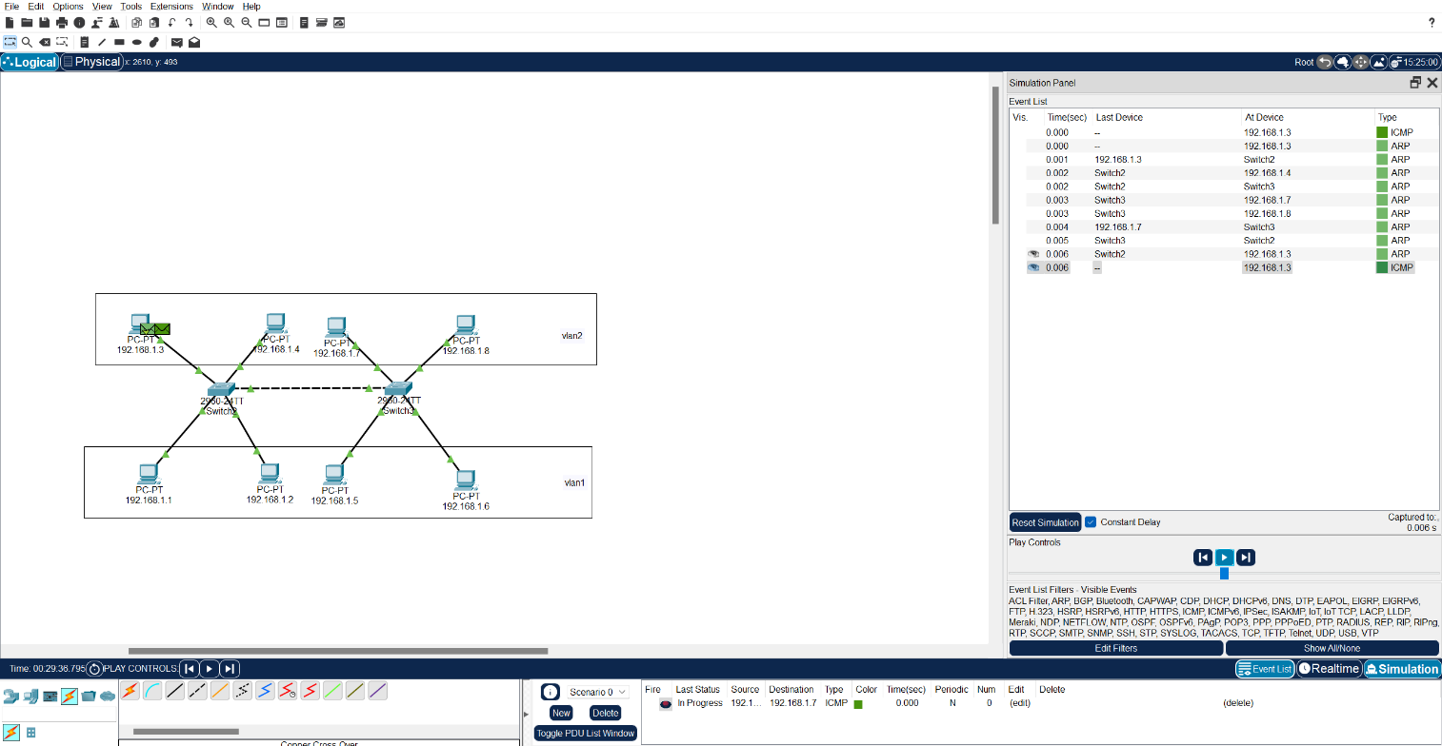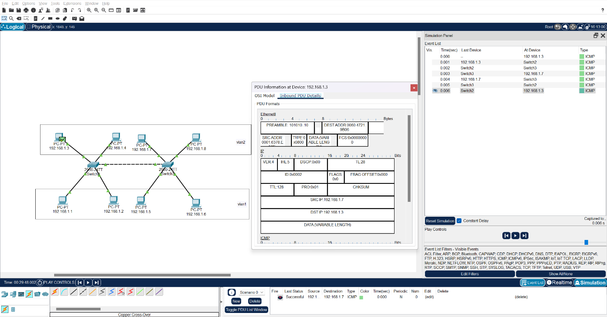

Write steps to create VLANs in packet tracer:

Step 1: Build the Network Topology

1. Open Cisco Packet Tracer.
2. Add the following devices:
   * One or more Switches
   * A few PCs (at least two for each VLAN you plan to create)
3. Use copper straight-through cables to connect PCs to the switch.

Step 2: Create VLANs on the Switch

1. Click on the switch → go to the Config tab.
2. Under VLAN Database, click Add and create:
   * VLAN 10 → Name: *Sales*
   * VLAN 20 → Name: *HR*
3. Assign switch ports to VLANs:
   * Example: FastEthernet0/1 → Access → VLAN 10
   * FastEthernet0/2 → Access → VLAN 20
4. For connections between switches (uplink ports like FastEthernet0/24), change the port mode to Trunk.
5. Double-check in the VLAN Database that your VLANs were created.

Step 3: Give IP Addresses to PCs

1. On each PC, go to Desktop → IP Configuration.
2. Assign IPs, for example:
   * PC1 (Sales VLAN): 192.168.10.2 / 255.255.255.0
   * PC2 (Sales VLAN): 192.168.10.3 / 255.255.255.0
   * PC3 (HR VLAN): 192.168.20.2 / 255.255.255.0
   * PC4 (HR VLAN): 192.168.20.3 / 255.255.255.0
3. (Optional) Label the PCs with their IP addresses in the topology so it’s easier to follow.

Step 4: Test the Setup

1. On a PC, open Command Prompt (Desktop → Command Prompt).
2. Use the ping command to test:
   * PCs in the same VLAN should be able to ping each other successfully.
   * PCs in different VLANs won’t communicate yet—unless you configure a router with sub-interfaces (router-on-a-stick).